1. Title & Abstract

Title
Academic Staff Recruitment System using React.js, Node.js, MongoDB, and API Integrations

Abstract
The recruitment process for academic staff is a critical task that requires an efficient and reliable system to handle applications, evaluations, and approvals. This project presents a web-based academic staff recruitment system that streamlines the application process using modern web technologies. The system is developed using React.js for the frontend, Node.js (Express.js) for the backend, and MongoDB as the database. Additionally, it integrates third-party services such as Amazon S3 for file storage, Twilio for notifications, and JWT-based authentication for security.
A key feature of this system is its integration with governmental APIs (e-Devlet & Nüfus Müdürlüğü) to validate applicant credentials and streamline the verification process. The system provides multiple user roles, including applicants, administrators, managers, and jury members, each with specific functionalities to manage applications, evaluate candidates, and finalize recruitment decisions.
This paper details the architecture, implementation, and functionalities of the system. The results indicate that the platform significantly reduces administrative overhead, improves application tracking, and enhances the efficiency of the recruitment process. Future improvements may include AI-driven candidate ranking and enhanced security mechanisms.
Keywords: Academic Recruitment, React.js, Node.js, MongoDB, API Integration, Authentication, AWS S3, Twilio.

2. Introduction

2.1 Background
The recruitment of academic staff plays a vital role in ensuring the quality of education and research in universities. Traditionally, this process involves manual submission of applications, document verification, and evaluation by selection committees, leading to inefficiencies such as delays, mismanagement of documents, and lack of transparency. With the growing need for digital transformation in academia, there is a demand for an automated system that streamlines this process while ensuring security, scalability, and integration with official government databases.

2.2 Objectives
The primary objective of this project is to develop a web-based academic recruitment system that allows institutions to manage applications digitally, ensuring:
- Seamless application submission for academic positions.
- Automated verification of applicants’ credentials using e-Devlet & Nüfus Müdürlüğü API.
- Secure document storage using Amazon S3.
- Multi-role system with distinct functionalities for applicants, administrators, managers, and jury members.
- Notification and communication system powered by Twilio.
- Authentication and access control using JWT.

2.3 Problem Statement
Existing recruitment processes in many academic institutions face several challenges:
- Time-consuming and inefficient workflows due to manual handling of applications.
- Document mismanagement, leading to lost or misplaced credentials.
- Lack of real-time updates, requiring candidates to frequently inquire about their application status.
- Limited integration with external verification systems, making it difficult to validate applicant credentials efficiently.
- Security risks in handling sensitive personal and academic data.
This project addresses these issues by implementing a modern, secure, and scalable recruitment platform that enhances the efficiency of the recruitment process.

2.4 Contributions
This system contributes to the academic recruitment process by:
- Automating the entire recruitment workflow, reducing administrative overhead.
- Providing a centralized platform for applicants, administrators, and evaluators.
- Ensuring security and integrity of applicant data through authentication and secure storage.
- Enhancing transparency by providing real-time application status updates.
- Facilitating document verification via API integration with government systems.

2.5 Organization of the Paper
The remainder of this paper is structured as follows:
- Section 3 describes the system architecture and the technologies used.
- Section 4 presents the system components, detailing the frontend, backend, database, authentication, and third-party integrations.
- Section 5 discusses the system’s functionalities and user roles.
- Section 6 provides insights into implementation details, including key code segments.
- Section 7 presents results, testing, and performance analysis.
- Section 8 concludes the paper and outlines future work.

3. System Architecture

3.1 Overview
The Academic Staff Recruitment System is designed as a web-based platform that follows a modern, scalable, and secure architecture. It is developed using a client-server model, where the frontend (React.js) interacts with the backend (Node.js/Express) via a RESTful API. The backend communicates with a MongoDB database (noSQL) for data persistence and integrates with external services such as Amazon S3 for file storage, Twilio for notifications, and e-Devlet & Nüfus Müdürlüğü APIs for identity verification.
The system is built with the following architectural considerations:
- Scalability: The modular architecture allows the system to scale efficiently.
- Security: Implements authentication, authorization, and secure API communications.
- Integration: Supports external API connections for validation and notifications.
- User Role Management: Handles multiple user types with different access levels.

3.2 Technologies Used
The system relies on a full-stack JavaScript ecosystem, with the following key technologies:
Component | Technology Used | Purpose
Frontend | React.js, Bootstrap | User interface design
Backend | Node.js, Express.js | API development and business logic
Database | MongoDB | Data storage and management
Authentication | JSON Web Token (JWT) | Secure user authentication
File Storage | Amazon S3 | Secure document upload and retrieval
Notifications | Twilio API | SMS/Email alerts for users
 | Brevo | Email alerts for users
API Integration | e-Devlet & Nüfus Müdürlüğü | Identity and document verification

3.3 System Architecture Diagram
The system follows a three-tier architecture, which consists of:
- Presentation Layer (Frontend): React.js handles the user interface, enabling users to interact with the system.
- Business Logic Layer (Backend): Node.js processes requests, implements authentication, and connects with external APIs.
- Data Layer (Database & External Services): MongoDB stores user and application data, while external APIs handle verification(E-devlet), file strorage (Amazon S3) and notifications(Twilo, Brevo).
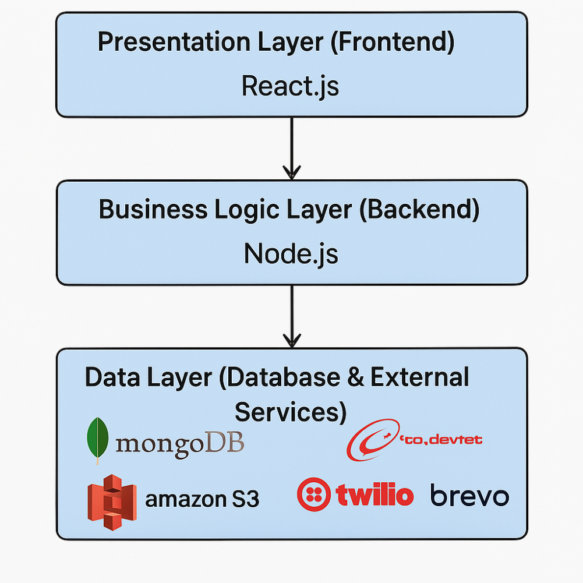

3.4 Interaction Flow
The system operates as follows:

Frontend (React.js & Bootstrap) - User Control, Registration & Authentication

4.1 Frontend (React.js & Bootstrap) - User Control, Registration & Authentication

Phase 1: Token Validation and User Redirection
- Token Check: When a user accesses the system, the application first checks for the presence of a valid JWT token in the browser’s local storage.
- Automatic Login: If a valid token is found, the user is automatically logged in, and a new JWT token is generated with a validity period of 7 more days. This process ensures that users don’t need to log in every time they visit the system within the token’s expiration period.
- No Token Found: If no valid token exists, or if it’s the user’s first visit to the system, the user is redirected to the ControlUser page to begin the registration process.

Phase 2: User Data Entry and e-Devlet API Verification
- Personal Information Submission: On the ControlUser page, users are required to enter essential personal details, such as TC Kimlik, Ad, Soyad, and Doğum Yılı.
- SOAP API Call: The entered data is sent to the backend, which then uses the SOAP protocol to query the e-Devlet API for user verification. This step ensures that the candidate exists in the government database.
  - Boolean Response: The backend returns a boolean indicating whether the user exists. If the user is not found, an error message is displayed to the user.
  - Verified User Redirection: If the user is found in the e-Devlet system, they are redirected to the login page to complete their registration.

Phase 3: User Registration and Authentication
- Completing Registration: On the login page, users are prompted to provide additional registration details, including their email, phone number, CV, and a signature image to be used on their application form.
- Authentication Process: Once the user submits this information, they are authenticated using their TC Kimlik and a password. At this point, a new JWT token is generated, and the user is logged in automatically.

Phase 4: Role Assignment and Access Control
- Default User Role: Initially, all new users are assigned the default role of user.
- Role Management: Only the system manager has the authority to modify user roles, allowing them to upgrade users to roles such as administrator or manager based on the requirements. This role-based access control ensures that users have appropriate permissions within the system.
Here can be the pseudo-code of the above process :
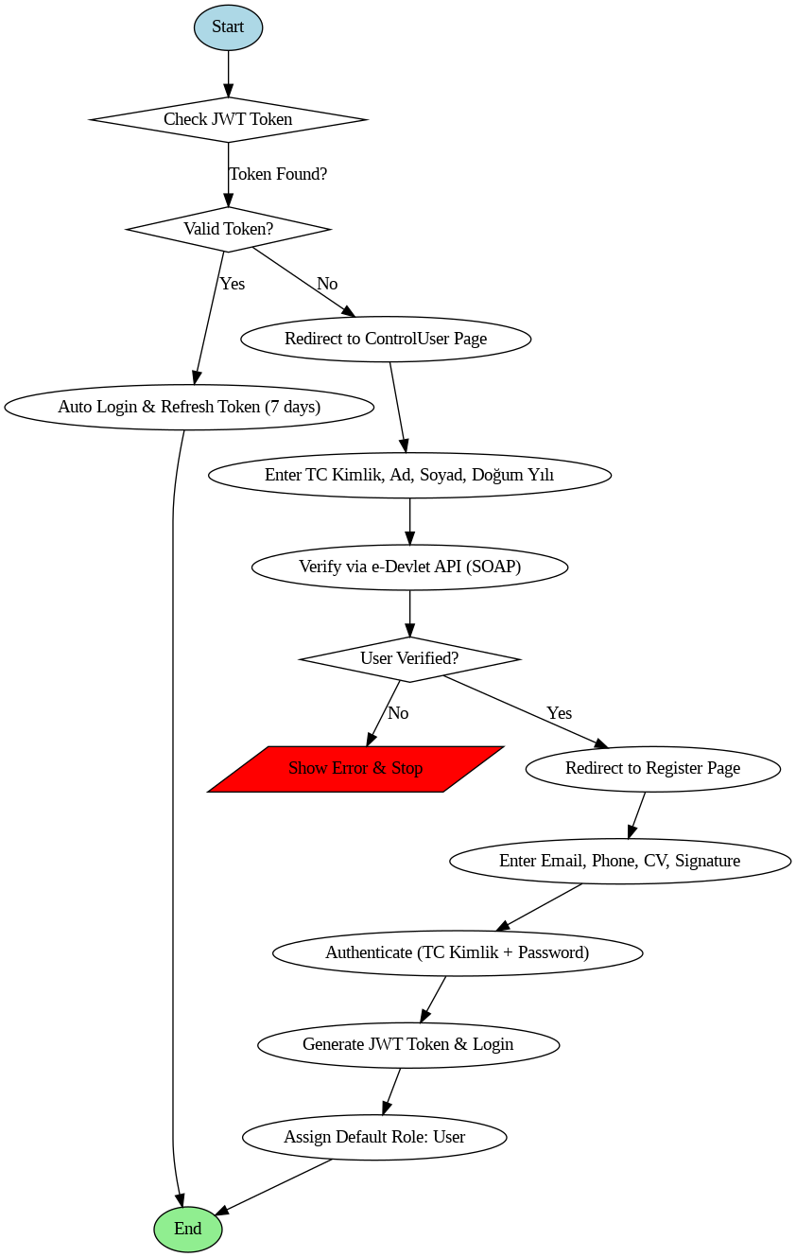

- Application Submission

4.2 Backend (Node.js & Express.js) - Application Submission
The application submission process is a critical component of the system, designed to streamline the application for academic positions by ensuring all candidate details are entered accurately and securely. It also ensures that the necessary documents are submitted and stored for later evaluation by the jury.

Phase 1: Accessing Job Announcements and Login/Registration
- Homepage: The homepage presents the latest academic job announcements, categorized by position type: Assistant Professor, Associate Professor, Professor, and All.
- Login/Registration: If the user is not logged in, they are redirected to the login or registration page. After successful login, the full job announcement is displayed. The user can then click the “Apply” button to proceed.

Phase 2: Dynamic Multi-Step Application Form
- Application Form Generation: After clicking the "Apply" button, the user is directed to a multi-step application form. The form is dynamically generated from the MongoDB "forms" collection, where each form is stored as a document. Each form corresponds to the categories of the KOÜ Atama Yo netmeligi Table 5.
- Form Structure:
  - Each form consists of 12 steps representing different categories in Table 5.
  - Each step includes a heading (H1) indicating the category (e.g., A Makaler), followed by a dropdown menu for selecting the appropriate activity within that category (e.g., 1 to 8 for Activity A).
- Filling Out the Form:
  - Once an activity is selected, a blank form appears, asking the candidate to fill in the necessary information and upload proof documents for that specific activity. These documents will be used by the jury to verify the validity of the information provided.
  - Candidates can fill out as many activities as needed from different categories but can only submit one activity per category at a time.
- Navigation Between Steps:
  - After completing a step, the candidate can click on "Next" or "Previous" to navigate through the form. The form allows flexibility, enabling users to fill in as many activities as necessary.

Phase 3: Review and PDF Generation
- Review Page: After completing the form, the user is directed to the "Review" page.
  - A PDF document is automatically generated, which includes all the completed activities, the points calculated according to KOÜ Atama Yo netmeligi Table 4, and the candidate’s signature (from the registration process).
  - The candidate is also presented with four radio buttons to choose the evaluation basis for the jury (Puanlanan Faaliyet Dönemi).
- PDF Customization:
  - The generated PDF contains the activities filled out by the candidate, their calculated points, and the candidate's signature. The system also includes the option for the user to review and modify any data in the form before finalizing the application.

Phase 4: Submission and Application Tracking
- Finalizing the Application:
  - Once the candidate reviews the details in the PDF and is satisfied with the information provided, they click the “Generate PDF” button to create the final document.
  - After the PDF is generated, the candidate clicks the “Submit Application” button to submit their application for review by the jury.
- Tracking Application Status:
  - The candidate is then redirected to the View Application page, where they can track the status of their application at any time. On this page, they can also download the generated PDF document of their application.

Document Storage and Security
- File Storage: All documents, including the candidate’s proof files and the final generated PDF, are securely stored on Amazon S3, ensuring safe and reliable storage with easy retrieval by authorized personnel.

- Verification & Evaluation
  - The system verifies applicants’ identity using e-Devlet & Nüfus Müdürlüğü API.
  - Administrators and jury members review applications.
- Notifications & Status Updates
  - Users receive SMS/Email alerts via Twilio regarding their application status.
- Final Decision & Recruitment
  - Approved candidates are notified, and their details are stored in the system for further processing.

Here is the updated System Components section, reflecting your use of fetch instead of Axios and React-native-dom Router instead of React Router.

4. System Components
This section provides a detailed breakdown of the key components of the Academic Staff Recruitment System, covering the frontend, backend, database, authentication, file storage, notifications, and external API integrations.

4.1 Frontend (React.js & Bootstrap)
The frontend of the system is built using React.js, a modern JavaScript library that enables dynamic and responsive user interfaces. Bootstrap is used for styling to ensure a professional and mobile-friendly design.

Key Features:
- User Authentication: Login and registration with role-based access.
- Dashboard: Personalized interfaces for applicants, administrators, and jury members.
- Application Management: Candidates can submit and track applications.
- Real-time Updates: Application status updates using API responses.

Main Technologies Used:
- React.js: Component-based architecture for efficient UI development.
- React-native-dom Router: Handles navigation between different views.
- Bootstrap: Ensures a responsive and clean user interface.
- Fetch API: Handles API calls to the backend without third-party libraries.

4.2 Backend (Node.js & Express.js)
The backend is developed using Node.js with the Express.js framework. It serves as the central hub that handles business logic, processes requests, and interacts with the database.

Key Features:
- RESTful API Development: Exposes endpoints for frontend interaction.
- Role-based Access Control: Manages different user permissions (Applicant, Administrator, Jury, Manager).
- Validation & Error Handling: Ensures data integrity and security.

Main Technologies Used:
- Node.js: Asynchronous and efficient backend processing.
- Express.js: Lightweight framework for building APIs.
- Mongoose: ORM for MongoDB integration.

4.3 Database (MongoDB)
The system uses MongoDB, a NoSQL database, for storing application-related data in a flexible JSON-like format.

Database Structure:
- Users Collection: Stores user information and roles.
- Applications Collection: Contains candidate applications.
- Documents Collection: Tracks uploaded documents.
- Reviews Collection: Stores jury evaluations.

Why MongoDB?
- Schema flexibility allows dynamic data storage.
- High scalability supports growing user data.
- Fast querying for real-time application tracking.

4.4 Authentication (JWT - JSON Web Token)
Authentication is implemented using JWT, ensuring secure user access and role management.

Authentication Process:
- Users register with email and password.
- The system verifies credentials and generates a JWT token.
- The token is sent with each request for secure API access.
- Middleware verifies tokens to allow access based on roles.

Security Measures:
- Password hashing using bcrypt.
- Token expiration to prevent unauthorized access.
- Role-based permissions for different user types.

4.5 File Storage (Amazon S3)
The system integrates AWS S3 for secure and scalable file storage.

Document Handling:
- Applicants upload necessary documents (CVs, certificates, etc.).
- Files are stored securely in Amazon S3 buckets.
- URLs are generated for controlled access.

Benefits of Amazon S3:
- Scalability: Handles large document storage efficiently.
- Security: Provides encrypted file storage.
- Accessibility: Fast retrieval and controlled access to files.

4.6 Notifications (Twilio API)
Twilio is integrated to send SMS and email notifications regarding application status updates.

Notification Workflow:
- When a candidate submits an application, they receive an SMS confirmation.
- Jury members get notifications when applications require review.
- Candidates receive status updates (approved, rejected, pending).

Benefits of Twilio Integration:
- Real-time communication keeps applicants informed.
- Automated alerts reduce manual follow-ups.

4.7 API Integrations (e-Devlet & Nüfus Müdürlüğü)
The system integrates with e-Devlet & Nüfus Müdürlüğü APIs to verify applicant information and documents.

Integration Steps:
- The system sends user details to the e-Devlet API for identity validation.
- The API responds with verification results.
- Approved applicants proceed to the next recruitment stage.

Why API Integration is Important?
- Authenticity: Ensures that only legitimate candidates apply.
- Automation: Reduces manual document checks.
- Efficiency: Speeds up the verification process.

5. Functionalities & User Roles
This section describes the core functionalities of the Academic Staff Recruitment System and details the different user roles involved in the platform. The system is designed to provide role-based access control, ensuring that each user has the necessary permissions to perform specific actions.

5.1 Core Functionalities
The system provides the following key functionalities:

1. User Authentication & Authorization
- Users can register and log in using JWT-based authentication.
- Role-based access ensures that different users have distinct permissions.

2. Application Submission & Tracking
- Applicants can fill out and submit their applications online.
- They can upload required documents, which are stored in Amazon S3.
- A dashboard allows applicants to track the status of their applications.

3. Document Verification & Validation
- The system verifies user details through the e-Devlet & Nüfus Müdürlüğü API.
- The verification process ensures that only valid applications are processed.

4. Review & Evaluation by Jury Members
- Jury members can access submitted applications for evaluation.
- They can approve, reject, or request additional documents.
- The review process is tracked, and evaluations are stored in the database.

5. Notification System (Twilio API)
- SMS and email notifications inform applicants about application status updates.
- Jury members receive alerts when applications require their attention.

6. Role-Based Dashboards
- Each user sees a dashboard tailored to their role:
  - Applicants: Track application progress and receive notifications.
  - Administrators: Manage user accounts, oversee applications, and handle disputes.
  - Jury Members: Review applications and submit evaluations.
  - Managers: Oversee the entire recruitment process and generate reports.

5.2 User Roles & Permissions
The system defines four main user roles, each with specific permissions:
Role | Permissions
Applicant | - Register & log in - Submit applications - Upload documents - Track application status - Receive notifications
Administrator | - Manage user accounts - Assign jury members - Oversee application processing - Handle disputes & system issues
Jury Member | - Review & evaluate applications - Approve or reject applications - Leave feedback for applicants
Manager | - Oversee entire recruitment process - Generate reports & analytics - Manage system-wide settings

5.3 System Workflow by User Role

1. Applicant Workflow
- Register and log in.
- Fill out an application form and upload required documents.
- Submit the application.
- Track application progress via the dashboard.
- Receive notifications regarding application status.

2. Jury Member Workflow
- Log in to the system.
- Access assigned applications.
- Review documents and verify credentials.
- Approve, reject, or request additional documents.
- Submit final evaluation.

3. Administrator Workflow
- Log in to the system.
- Manage user accounts (approve/reject new users).
- Oversee the application review process.
- Assign jury members to applications.
- Resolve disputes or system issues.

4. Manager Workflow
- Log in to the system.
- Oversee the entire recruitment process.
- Generate reports on application trends.
- Optimize workflows and system settings.

6. Implementation Details
This section outlines the technical implementation of the Academic Staff Recruitment System, focusing on the frontend, backend, database, authentication, storage, notifications, and API integrations.

6.1 Frontend Implementation
The frontend is built with React.js and uses Bootstrap for styling. It follows a component-based architecture, ensuring modularity and reusability.

Key Implementation Details:
- Routing: Implemented using React-native-dom Router for navigation.
- State Management: React’s useState and useEffect hooks are used for handling state changes.
- API Calls: Fetch API is used for communication with the backend.

Example API Call using Fetch:
fetch('https://api.example.com/applications', {
method: 'GET',
headers: {
'Authorization': `Bearer ${token}`,
'Content-Type': 'application/json'
}
})
.then(response => response.json())
.then(data => console.log(data))
.catch(error => console.error('Error:', error));

Component Breakdown:
- LoginForm.jsx – Handles user authentication.
- Dashboard.jsx – Displays user-specific dashboard.
- ApplicationForm.jsx – Allows applicants to submit applications.
- JuryReview.jsx – Jury members review applications.

6.2 Backend Implementation
The backend is developed using Node.js with Express.js to handle requests, process business logic, and manage the database.

Key Implementation Details:
- Routing: Express.js is used to define RESTful API routes.
- Middleware: JSON Web Token (JWT) authentication is implemented.
- Database Communication: Mongoose is used for MongoDB interactions.

Example Express.js Route:
const express = require('express');
const router = express.Router();
const Application = require('../models/Application');
const authMiddleware = require('../middleware/auth');

// Get all applications
router.get('/applications', authMiddleware, async (req, res) => {
try {
const applications = await Application.find();
res.json(applications);
} catch (error) {
res.status(500).json({ message: 'Server Error' });
}
});

module.exports = router;

6.3 Database Implementation (MongoDB)
The system uses MongoDB, a NoSQL database, to store user and application data.

Database Schema Examples:
User Schema:
const mongoose = require('mongoose');

const UserSchema = new mongoose.Schema({
name: String,
email: { type: String, unique: true },
password: String,
role: { type: String, enum: ['applicant', 'administrator', 'jury', 'manager'] }
});

module.exports = mongoose.model('User', UserSchema);
Application Schema:
const ApplicationSchema = new mongoose.Schema({
applicantId: mongoose.Schema.Types.ObjectId,
documents: [String],
status: { type: String, enum: ['pending', 'approved', 'rejected'], default: 'pending' }
});

module.exports = mongoose.model('Application', ApplicationSchema);

6.4 Authentication (JWT - JSON Web Token)
User authentication is managed using JWT, which securely verifies and maintains user sessions.

Authentication Flow:
- The user logs in and provides credentials.
- The system validates credentials and generates a JWT token.
- The token is used for secure API access.
- Middleware ensures only authorized users can access specific endpoints.

Example Login Implementation:
const jwt = require('jsonwebtoken');

app.post('/login', async (req, res) => {
const user = await User.findOne({ email: req.body.email });
if (!user) return res.status(400).json({ message: 'User not found' });

const token = jwt.sign({ id: user._id, role: user.role }, 'secretKey', { expiresIn: '1h' });
res.json({ token });
});

6.5 File Storage (Amazon S3)
The system uses Amazon S3 for secure file uploads and document storage.

File Upload Workflow:
- The user uploads a document.
- The file is stored in an S3 bucket.
- The system generates a secure URL for access.

Example S3 File Upload:
const AWS = require('aws-sdk');
const s3 = new AWS.S3();

const uploadFile = (file) => {
const params = {
Bucket: 'academic-portal',
Key: file.name,
Body: file.data
};
return s3.upload(params).promise();
};

6.6 Notification System (Twilio API)
Twilio is integrated to send SMS and email notifications regarding application status updates.

Example Twilio Integration:
const twilio = require('twilio');
const client = new twilio('ACCOUNT_SID', 'AUTH_TOKEN');

client.messages.create({
body: 'Your application has been approved!',
from: '+1234567890',
to: '+9876543210'
})
.then(message => console.log('Message sent:', message.sid))
.catch(error => console.error('Error:', error));

6.7 API Integrations (e-Devlet & Nüfus Müdürlüğü)
The system integrates with e-Devlet & Nüfus Müdürlüğü APIs for applicant verification.

Integration Process:
- The system sends applicant data to e-Devlet API.
- The API validates the data and responds with verification results.
- The system updates the application status accordingly.

Example API Request:
fetch('https://edevlet.api/validate', {
method: 'POST',
headers: { 'Content-Type': 'application/json' },
body: JSON.stringify({ nationalId: '12345678901' })
})
.then(response => response.json())
.then(data => console.log('Verification Status:', data.status))
.catch(error => console.error('Error:', error));

Here is the detailed version of the IEEE report structure based on section 7 ("Results & Discussion") in English:

7. Results & Discussion
This section should present the outcomes of the project, including the testing performed, the results obtained, and a discussion of the challenges and performance of the system.

7.1 Tests Performed
- Unit and Integration Tests: Describe the testing strategies used, the types of tests performed (unit, integration, or end-to-end tests), and the tools used for testing (such as Jest, Mocha, etc.).
  - Example: “Unit tests were conducted on individual React components to ensure proper functionality, while integration tests validated the interaction between the backend (Node.js) and the database (MongoDB).”
- Performance Testing Results: Include results from stress tests, load tests, or any other performance benchmarks conducted to assess the scalability and responsiveness of the system.
  - Example: “The system was tested with 1000 concurrent users, and the response time remained under 2 seconds for 90% of the requests, demonstrating good scalability.”

7.2 Issues Encountered and Solutions
- Technical Difficulties: Explain any challenges faced during the development and deployment of the project, such as issues with API integrations, security problems, or difficulties with handling file uploads.
  - Example: “One of the main challenges was integrating the e-Devlet API due to the strict authentication requirements. The issue was resolved by implementing OAuth2 for secure access.”
- Workarounds and Fixes: Describe any workarounds or solutions applied to overcome the technical difficulties.
  - Example: “To resolve issues with S3 file storage permissions, we adjusted the access control policies to allow only specific user roles to upload and download documents.”

7.3 Performance Analysis
- System Responsiveness: Discuss how quickly the system responds to user actions, such as submitting a form or retrieving application data, and how it handles multiple users or large datasets.
  - Example: “The front-end, powered by React.js, was optimized for fast rendering, reducing load times by 30% through the implementation of lazy loading for non-critical assets.”
- Scalability: Explain how the system scales when the number of users or requests increases. This could include database optimizations, server-side load balancing, or other scalability techniques.
  - Example: “MongoDB’s flexible schema allowed the database to handle diverse candidate data without significant performance loss, and AWS S3 provided scalable storage for an increasing volume of uploaded documents.”
- Security & Stability: Analyze the security and stability of the system, especially concerning data protection, authentication, and prevention of unauthorized access.
  - Example: “JWT-based authentication provided secure login sessions, and data encryption ensured that sensitive candidate information was protected at rest and in transit.”

Here’s the continuation for the remaining sections of the IEEE report structure:

8. Conclusion & Future Work
This section summarizes the achievements of the project, highlights its strengths, and outlines potential areas for future improvements.

8.1 Summary of Project Achievements
- Project Accomplishments: Recap the main objectives of the project and how they were achieved. Include key highlights such as successful implementation of features, integration with third-party services, and performance outcomes.
  - Example: “The project successfully implemented an academic application system that allows candidates to submit applications, receive notifications, and be evaluated by a jury. The integration of e-Devlet and Nüfus Müdürlüğü APIs streamlined candidate verification, while AWS S3 ensured reliable document storage.”

8.2 Areas for Improvement and Future Enhancements
- Potential Improvements: Discuss any areas where the system could be enhanced, such as additional features, better user interface design, or improved performance.
  - Example: “Future enhancements could include adding machine learning models to assist juries in evaluating candidates’ applications more efficiently. Additionally, a mobile application version could improve accessibility for users on the go.”
- Long-Term Vision: Propose long-term goals for the project, such as broader adoption, scaling the system for use in other institutions, or adding more third-party integrations.
  - Example: “In the long term, the system could be scaled to support multiple universities, allowing candidates to apply to different academic programs with a single account. Further integrations with other government agencies could improve the verification process.”

9. References
This section lists all the sources referenced throughout the report, including academic papers, official documentation, books, or websites that provided valuable insights during the development of the project.

9.1 Citation of Resources
- Books & Articles: Provide references to any academic or technical articles that guided your understanding of the technologies or methodologies used.
  - Example: “[1] Author, Title of Book, Publisher, Year of Publication.”
- Documentation: Include references to documentation for technologies or frameworks used, such as React.js, Node.js, MongoDB, AWS, Twilio, JWT, etc.
  - Example: “[2] React.js Documentation. https://reactjs.org/docs.”
- Tools and Libraries: Mention any libraries, tools, or frameworks used for the project.
  - Example: “[3] Express.js Documentation. https://expressjs.com.”
- Websites & Online Resources: Reference any online guides, tutorials, or community contributions that were particularly helpful.
  - Example: “[4] Twilio API Documentation. https://www.twilio.com/docs.”

